
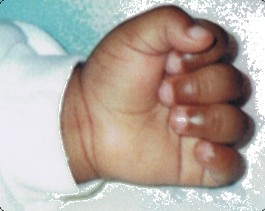
Pledge Form

Coulson Sickle Cell Foundation of S.L.

Please support Coulson Foundation of Sierra Leone by pledging your donation to the opening of our clinic in Freetown. With your donation the clinic will be equipped to screen mothers, babies and children for sickle cell disease. And if detected, our facility will be available to the public; to do follow up services for our patients by providing pain medications, antibiotics, folic acids, nutrition and diet, and also clean drinking water. The center will be able to provide vaccination for children and mothers. There will also be parental education and comprehensive care from our medical staffs, which can educate and reduce the mortality from the disease in infant and early childhood.

To get more information about CSCF, please visit our Website at www.coulsonsicklecell.org.

Donor Information (please print or type)
Name
Billing address
City
State
ZIP Code
Telephone (home)
Telephone (business)
Fax
E-Mail

Pledge Information
I (we) pledge a total of $_______________to be paid:
____ now ____ monthly ____ quarterly ____ yearly.
I (we) plan to make this contribution in the form of:
____ cash ____ check ____ credit card thru CSCF Website: www.coulsonsicklecell.org .
Gift will be matched by ________________________________ (company/family/foundation).
____ form enclosed ____ form will be forwarded

Acknowledgement Information
Please use the following name(s) in all acknowledgements:
____ I (we) wish to have our gift remain anonymous.
Signature(s)
Date
Please make checks, corporate matches, or other gifts payable to:
Coulson Sickle Cell Foundation of Sierra Leone
P.O. Box 81605, Conyers, GA 30013 Phone: (770) 362-6735 Fax: (770) 679-9477

